**Security Assessment Findings Report**

Business Confidential

*Date: September 20th, 2024*

*Project: 897-19*

*Version 1.0*

# Table of Contents

**Table of Contents 2**

**Confidentiality Statement 3**

**Disclaimer 3**

**Contact Information 3**

**Assessment Overview 4**

**Assessment Components 4**

External Penetration Test 4

**Finding Severity Ratings 5**

**Scope 6**

Scope Exclusions 6

Client Allowances 6

**Executive Summary 7**

Attack Summary 7

**Security Strengths 8**

SIEM alerts of vulnerability scans 8

**Security Weaknesses 8**

Missing Multi-Factor Authentication 8

Weak Password Policy 8

Unrestricted Logon Attempts 8

**Vulnerabilities by Impact 9**

External Penetration Test Findings 10

Insufficient Lockout Policy – Outlook Web App (Critical) 10

Additional Reports and Scans (Informational) 13

# **Confidentiality Statement**

This document is the exclusive property of Demo Company (DC) and Xami. This document contains proprietary and confidential information. Duplication, redistribution, or use, in whole or in part, in any form, requires consent of both DC and Xami.

Xami may share this document with auditors under non-disclosure agreements to demonstrate penetration test requirement compliance.

# **Disclaimer**

A penetration test is considered a snapshot in time. The findings and recommendations reflect the information gathered during the assessment and not any changes or modifications made outside of that period.

Time-limited engagements do not allow for a full evaluation of all security controls. Xami prioritized the assessment to identify the weakest security controls an attacker would exploit. Xami recommends conducting similar assessments on an annual basis by internal or third-party assessors to ensure the continued success of the controls.

# **Assessment Overview**

From September 20th, 2024 to September 25th, 2024, DC engaged Xami to evaluate the security posture of its infrastructure compared to current industry best practices that included an external penetration test. All testing performed is based on the NIST *SP 800-115 Technical Guide to Information Security Testing and Assessment, OWASP Testing Guide (v4), and customized testing frameworks*.

Phases of penetration testing activities include the following:

* Planning – Customer goals are gathered and rules of engagement obtained.
* Discovery – Perform scanning and enumeration to identify potential vulnerabilities, weak areas, and exploits.
* Attack – Confirm potential vulnerabilities through exploitation and perform additional discovery upon new access.
* Reporting – Document all found vulnerabilities and exploits, failed attempts, and company strengths and weaknesses.

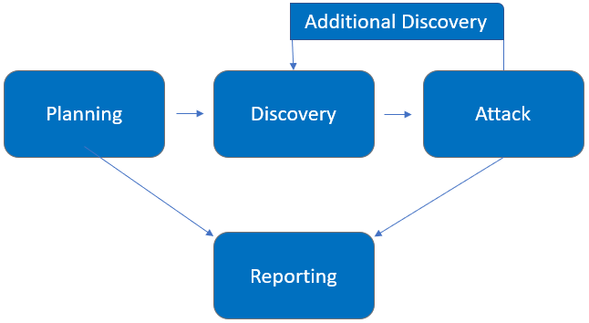

# **Assessment Components**

## **External Penetration Test**

An external penetration test emulates the role of an attacker attempting to gain access to an internal network without internal resources or inside knowledge. An engineer attempts to gather sensitive information through open-source intelligence (OSINT), including employee information, historical breached passwords, and more that can be leveraged against external systems to gain internal network access. The engineer also performs scanning and enumeration to identify potential vulnerabilities in hopes of exploitation.

# **Finding Severity Ratings**

The following table defines levels of severity and corresponding CVSS score range that are used throughout the document to assess vulnerability and risk impact.

| **Severity** | **CVSS V3 Score Range** | **Definition** |
| --- | --- | --- |
| **Critical** | 9.0-10.0 | Exploitation is straightforward and usually results in system-level compromise. It is advised to form a plan of action and patch immediately. |
| **High** | 7.0-8.9 | Exploitation is more difficult but could cause elevated privileges and potentially a loss of data or downtime. It is advised to form a plan of action and patch as soon as possible. |
| **Moderate** | 4.0-6.9 | Vulnerabilities exist but are not exploitable or require extra steps such as social engineering. It is advised to form a plan of action and patch after high-priority issues have been resolved. |
| **Low** | 0.1-3.9 | Vulnerabilities are non-exploitable but would reduce an organization’s attack surface. It is advised to form a plan of action and patch during the next maintenance window. |
| **Informational** | N/A | No vulnerability exists. Additional information is provided regarding items noticed during testing, strong controls, and additional documentation. |

# **Scope**

| **Assessment** | **Details** |
| --- | --- |
| External Penetration Test | 192.168.0.0/24,  192.168.1.0/24 |

* Full scope information provided in “**Demo Company-867-19 Full Findings.xslx”**

## **Scope Exclusions**

Per client request, Xami did not perform any Denial of Service attacks during testing.

## **Client Allowances**

DC did not provide any allowances to assist the testing.

# **Executive Summary**

Xami evaluated DC’s external security posture through an external network penetration test from September 20th, 2024 to September 25th, 2024. By leveraging a series of attacks, Xami found critical level vulnerabilities that allowed full internal network access to the DC headquarter office. It is highly recommended that DC address these vulnerabilities as soon as possible as the vulnerabilities are easily found through basic reconnaissance and exploitable without much effort.

## **Attack Summary**

The following table describes how Xami gained internal network access, step by step:

| **Step** | **Action** | **Recommendation** |
| --- | --- | --- |
| 1 | Obtained historical breached account credentials to leverage against all company login pages | Discourage employees from using work e-mails and usernames as login credentials to other services unless necessary |
| 2 | Attempted a “credential stuffing” attack against Outlook Web Access (OWA), which was unsuccessful. However, OWA provided username enumeration, which allowed Xami to gather a list of valid usernames to leverage in further attacks. | Synchronize valid and invalid account messages. |
| 3 | Performed a “password spraying” attack against OWA using the usernames discovered in step 2. Xami used the password of Summer2018! (season + year + special character) against all valid accounts and gained access into the OWA application. | OWA permitted authenticated with valid credentials. Xami recommends DC implement Multi-Factor Authentication (MFA) on all external services.  OWA permitted unlimited login attempts. Xami recommends DC restrict logon attempts against their service.  Xami recommends an improved password policy of: 1) 14 characters or longer 2) Use different passwords for each account accessed. 3) Do not use words and proper names in passwords, regardless of language  Additionally, Xami recommends that DC:   * Train employees on how to create a proper password |
| 4 | Leveraged valid credentials to log into VPN | OWA permitted authenticated with valid credentials. Xami recommends DC implement Multi-Factor Authentication (MFA) on all external services. |

# **Security Strengths**

## **SIEM alerts of vulnerability scans**

During the assessment, the DC security team alerted Xami of detected vulnerability scanning against their systems. Xami was successfully able to identify the engineer’s attacker IP address within minutes of scanning and was capable of blacklisting IP from further scanning actions.

**NOTE: This was a controlled experiment**

# **Security Weaknesses**

## **Missing Multi-Factor Authentication**

Xami leveraged multiple attacks against DC login forms using valid credentials harvested through open-source intelligence. Successful logins included employee e-mail accounts through Outlook Web Access and internal access via Active Directory login on the VPN. The use of multi-factor authentication would have prevented full access and required Xami to utilize additional attack methods to gain internal network access.

## **Weak Password Policy**

Xami successfully performed password guessing attacks against DC login forms, providing internal network access. A predictable password format of Summer2018! (season + year + special character) was attempted and successful.

## **Unrestricted Login Attempts**

During the assessment, Xami performed multiple brute-force attacks against login forms found on the external network. For all logins, unlimited attempts were allowed, which permitted an eventual successful login on the Outlook Web Access application.

# **Vulnerabilities by Impact**

The following chart illustrates the vulnerabilities found by impact:

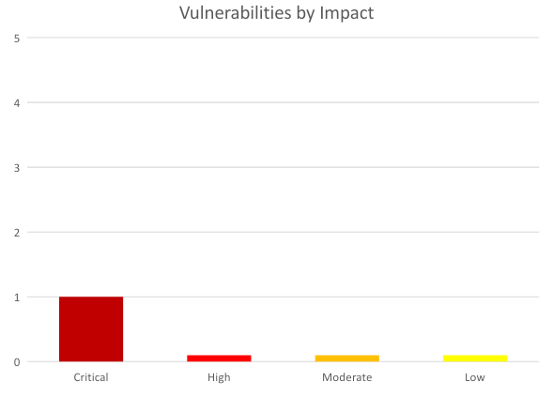

## **External Penetration Test Findings**

**Insufficient Lockout Policy – Outlook Web App (Critical)**

| **Description:** | DC allowed unlimited login attempts against their Outlook Web App (OWA) services. This configuration allowed brute force and password guessing attacks in which Xami used to gain access to DC’s internal network. |
| --- | --- |
| **Impact:** | Critical |
| **System:** | 192.168.0.5 |
| **References:** | [NIST SP800-53r4 AC-17](https://nvd.nist.gov/800-53/Rev4/control/AC-17) - Remote Access  [NIST SP800-53r4 AC-7(1)](https://nvd.nist.gov/800-53/Rev4/control/AC-7#enhancement-1) - Unsuccessful Login Attempts |Automatic Account Lock |

**Exploitation Proof of Concept**

Xami gathered historical breached data found in credentials dumps. The data amounted to 868 total account credentials (**Note:** A full list of compromised accounts can be found in “**Demo Company-867-19 Full Findings.xslx”**.).

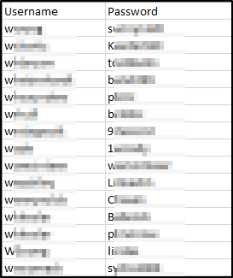

*Figure 1: Sample list of breached user credentials*

Xami used the gathered credentials to perform a credential stuffing attack against the OWA login page. Credential stuffing attacks take previously known credentials and attempt to use them on login forms to gain access to company resources. Xami was unsuccessful in the attack but was able to gather additional sensitive information from the OWA server in the form of username enumeration.

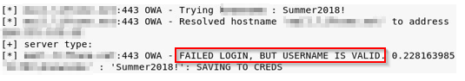

*Figure 2: OWA username enumeration*

Xami gathered the valid usernames and performed a password spraying attack. A password spraying attack attempts to use common passwords against known usernames in hopes of gaining access to company resources. Xami attempted to use the common Summer2018! (season + year + special character) against all known valid usernames. A username returned as a successful login:

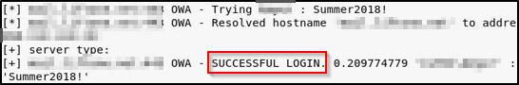

*Figure 3: Successful OWA Login*

Xami leveraged the valid credentials to log into the client VPN portal and gain access to the internal network.

**Remediation**

| **Who:** | IT Team |
| --- | --- |
| **Vector:** | Remote |
| **Action:** | Item 1: VPN and OWA login with valid credentials did not require Multi-Factor Authentication (MFA). Xami recommends DC implement and enforce MFA across all external-facing login services.  Item 2: OWA permitted unlimited login attempts. Xami recommends DC restrict logon attempts against their service.  Item 3: DC permitted a successful login via a password spraying attack, signifying a weak password policy. Xami recommends the following password policy, per the Center for Internet Security (CIS):   * 14 characters or longer * Use different passwords for each account accessed * Do not use words and proper names in passwords, regardless of language   Item 4: OWA permitted user enumeration. Xami recommends DC synchronize valid and invalid account messages.  Additionally, Xami recommends that DC:   * Train employees on how to create a proper password * Check employee credentials against known breached passwords * Discourage employees from using work e-mails and usernames as login credentials to other services unless absolutely necessary |

**Additional Reports and Scans (Informational)**

Xami provides all clients with all report information gathered during testing. This includes vulnerability scans and a detailed findings spreadsheet. For more information, please see the following documents:

* **Demo Company-867-19 Full Findings.xslx**
* **Demo Company-867-19 Vulnerability Scan Summary.xslx**
* **Demo Company-867-19 Vulnerability Scan by Host.pdf**